Hillcrest Primary School Attendance Policy

PURPOSE
The Department of Education and Children’s development (DECD) is accountable to the community, through the Minister for Education and Children’s Development, for ensuring appropriate attendance in government educational programs.

This policy is based on the following principles:
- Families, society, peers and educators and other significant adults influence the life choices of young people.
- Attendance has benefits and consequences that increase and decrease life choices.
- Individuals are able to accept responsibility for their participation in education programs.
- Continuity of relationships and learning in an educational program is dependent upon attendance.
- Attendance is a shared responsibility between the staff of preschools and schools, parents/caregivers, children and students, and members of the wider community.
- Attendance is critically linked to the quality of curriculum, teaching and learning and the development of relationships, which then foster improved learning outcomes and increased wellbeing for individuals and social skills.
- Participation in educational programs fosters the development of personal and social skills.

RATIONALE
Punctuality and regular attendance at school are very important from the very first day to allow consolidation of learning and to prevent “gaps” of learning appearing in a child’s learning path. If students miss the basic skills in the early years of school, they often experience difficulties making the transition to secondary school, as habits of poor attendance become ingrained. Students who are frequently absent, late or depart early may also experience:
- Lack of continuity and familiarity, resulting in them feeling less secure within the school environment.
- Loss of opportunity for play activities which improve social/emotional, physical and cognitive development.
- Isolation, which may lead to bullying or teasing.
- Loss of self-esteem and self-confidence.
- Reduced opportunities in employment and further education.
- Over-representation in the Juvenile Justice System.

EXPECTATIONS
A child who is at least six years old but not yet seventeen is of compulsory school age and is expected to attend school on every day that instruction is provided at the school for the child unless:
- They are too sick to attend.
- Incapacitated by injury preventing movement around the school.
- Are accompanying his/her parents or caregivers on a family holiday or culturally significant day which cannot be arranged in school vacations. (This should be arranged with the Principal prior to the absence).
Hillcrest Primary School is expected to:
- Aim to achieve 100% attendance for all students.
- Follow up all absences.
- Counsel students and their families about the impact of attendance on achievement.

At Hillcrest Primary we:
- Promote regular attendance at school to help establish routines and habits that transfer to all school and work settings.
- Encourage enrolment and attendance at preschool to ensure school readiness.
- Monitor rates and trends of attendance daily.
- Ensure consistency of message to parents/caregivers and students from teachers.
- Discuss with families about the need for regular attendance.
- Send letters home to parents/caregivers asking them to explain absence.
- Refer chronic attendance concerns to leadership.
Through our newsletter we regularly communicate to our community:
- The benefits of regular attendance for students, staff, parents and community.
- Policies and procedures that are in place, so they can be understood by all.
- Intervention strategies being used.

STRATEGIES
- The Front Office keeps a register of late arrivals and early departures. Parents/caregivers must sign in or out and provide a reason. The parent/caregiver must present a card from the Front Office to the classroom teacher when arriving late, or collecting a child early.

- Parents/caregivers are reminded several times per term via newsletter articles about the requirement of notifying the Front Office when students are away and of the importance of regular attendance and punctuality.

- When a pattern of excessive absence or lateness becomes apparent, the Deputy Principal or the Principal contacts the family and invites them to a meeting to discuss the problem and to put in place a support plan – if unable to contact via phone, a registered mail letter will be sent home.

- If the problem continues or the family is unwilling to work on the matter, the problem will be referred to the social work duty line (1300 620 673).

Explanation of absence
Where a child of compulsory school age is absent from school the parent/caregiver is required to present a written explanation for that absence within a reasonable time. In general, this explanation should be received within three days of the commencement of the absence. The Principal may use his/her discretion about accepting a telephone message in place of a written note. Where a written explanation is not received within a reasonable time, the leadership team should contact the parent or caregiver. If contact cannot be made by telephone or in person, leadership team to ring the social work duty line.

All written explanations, replies to absentee notes, medical certificates and documentation are to be kept at the school and filed in students files. The teacher must endorse each such note with the date on which it was received at the school. Written explanations in school diaries will be considered acceptable if the school uses such diaries. Class Dojo notes are recorded by Callum on EDSAS. Schools must document all information relating to non-attendance, e.g. telephone calls and contact with homes on EDSAS.

What assistance is available?
There are many staff members who can assist you if attendance is an issue for your child. You can discuss your concerns with your child’s teacher, Deputy Principal or Principal (in school).

RESPONSIBILITIES AND ACTIONS

Role | Authority / Responsibility for
Leadership | - Train staff on the roles and responsibilities regarding student attendance, including the induction of new staff throughout the year.  - Provide teaching staff with Attendance Policy and proformas used for documenting attendance.  - Analyse attendance data each term to identify students at risk. The attendance report will be produced at the end of each term and provided to classroom teachers for their own analysis of student attendance.  - Support class teachers as stated in the Hillcrest Primary School Attendance Plan.  - Write articles for the newsletter regarding the importance for regular attendance and being on time for school.  - Meet with Student Attendance Counsellor as required.  - The Principal has delegated authority from the Minister to approve applications for temporary exemption from school attendance for periods up to one calendar month. Parents/caregivers should apply in writing and principals should advise approvals and non-approvals on school letterhead. Copies of such advices are to be retained in the school files, together with applications, and are to be made available to appropriate Department Officers as required.  - All applicants for temporary exemptions exceeding one week, and for permanent exemptions, are to be set out on Form ED175 and forwarded to the Regional Office.  - To notify school community of early dismissals. No more than 4 times a year and up to 1 hour before the normal end of the school day.
School Staff | - Record absences and reason for absences in class room roll book and send to the front office by 9:30am daily.  - Record student lateness and keep a record of time of arrival in class roll book.  - Teachers will contact families if a student in their class has an unexplained absence or they notice a pattern of non-attendance emerging.  - Notify the Deputy Principal and the Front Office when they notice that a child has had 3 days unexplained absence in a row and they have been unable to contact the parent/caregivers. Further attempts to contact parents/caregivers (including phone calls to emergency contacts, letters, home visits) will be made enquiring about the reason for the absence.  - Any staff initiated interventions regarding lateness/absences must be documented.  - Follow guidelines stated in the Hillcrest Primary School Attendance Plan.  - If unable to make contact with parent/caregiver, see leadership.  - Teachers will, if required, supervise students until the normal school day (3:00 pm) for early dismissal days.
Parents / Care givers responsibilities | - Upon enrolment, parents/caregivers are to provide information to the school that may assist in planning for the child’s learning and wellbeing; e.g. medical conditions, emergency contacts, developmental milestones and family issues.  - Parents/caregivers are responsible for enabling their child to attend punctually (8:50am) and daily when instruction is offered unless the school receives a valid reason for being absent (e.g. illness).  - Parents/caregivers must provide the school with an explanation to the school whenever their child is absent via telephone on the day of the absence and / or followed up by a diary note on the student’s return to school. Parents/caregivers are to provide a medical certificate where appropriate for extended absences.  - When a student is late for school, it is appropriate that the parent/caregiver explains the reason for lateness.  - Parents/caregivers must let the school know if an extended absence is likely or if the school needs to arrange work at home for students.  - For temporary exemption from school (e.g. family holiday overseas) parents/caregivers must notify the Principal prior to the absence and fill out an ED 175 form. Depending on the length of exemption, this form will be sent to Central Office.  - Work with the school on intervention strategies to improve attendance.  - Discuss with the Principal any suspicions of neglect and/or abuse that may require a mandatory notification.  - Parents are to provide written consent for early dismissals. A Consent form can be found in new enrolment packs.  - Parents are to inform leadership before time if their child requires supervision until normal dismissal time (3:00pm) on early dismissal days. OSHC will also be available for families if they prefer at a small additional cost to the normal session fee.
Students | - Attend school or other educational programs offered every day.  - Be punctual in arriving at school  - Engage appropriately in the education program.

UNSATISFACTORY ATTENDANCE
The principal or delegate may need to remind the parents/caregivers about legal obligations for attendance of students under compulsion. The Principal or delegate may contact the social work duty line for assistance. As a last resort, a Truancy Social Worker will prosecute the parents/caregivers for non-attendance of a student of compulsory school age.

Truancy Social Workers from the social work duty line provides the following services:
- Help schools to develop and implement strategies and plans that foster resilience in children and young people and address their social, emotional and educational needs.
- Collaborate with child wellbeing practitioners, child protection services and other relevant agencies.
- Deliver services directly with children and their families, build capacity within school and develop and support community connections.

Outcomes
The social work- truancy service specifically aims for:
- Improved attendance rates and engagement of all children and young people in school settings.
- Improved resilience and social and emotional wellbeing of children and young people.
- Strengthened family links and engagement with schools.
- Improved systemically embedded processes in all schools to effectively engage all children and young people in an environment of inclusive practice.
- All schools to plan implementation of effective evidence-informed strategies to support the social and emotional wellbeing of all students

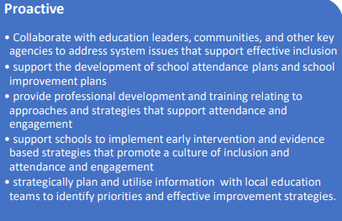
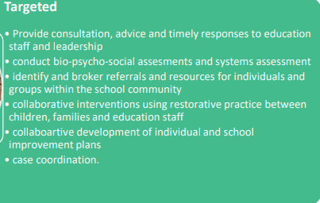
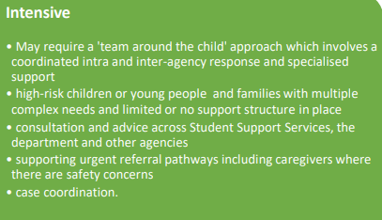
Service Model
Prosecution of parents for the non-attendance of a child:
- Section 76(1) of the Education Act states that a child is required to attend the school at which he/she is enrolled on every day instruction is provided by the school for the child.
- Section 76(3) states that where a child fails to attend school each parent of the child shall be guilty of an offence and liable to a penalty not exceeding two hundred dollars.
- Prosecution of parents/caregivers is a last resort for persistent non-attendance of students of compulsory school age.

Ratified by staff and Governing Council:
Review date: March 2025

